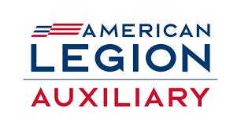
American Legion Auxiliary
Department of Connecticut

Polo Shirt Fundraiser

Three color choices to choose from

Red or Blue Polos with new branding logo in white

White Polo with new branding logo in color

Available in sizes xs-4XL in both Women’s and Men’s cut.
Only $25.00 each.
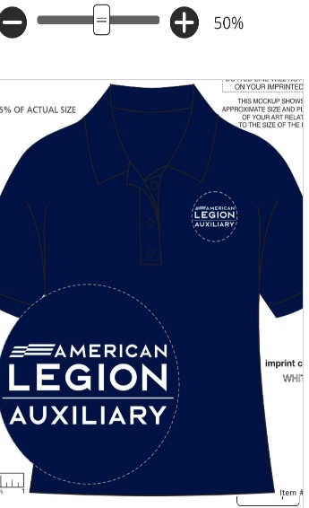
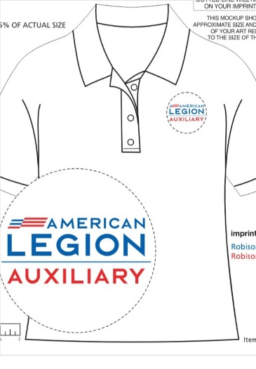
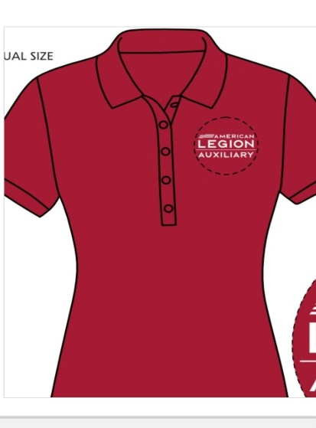

Show your support for the American Legion Auxiliary,
Embroidered with the NEW Auxiliary logo!

Polo Shirt Order Form

Name: _________________________ Unit #_________
Phone# _____________ Email ____________________

Women’s Cut ___XS ____SM _____MED ____LG
RED ____XL _____2XL _____3XL ____4XL

Women’s Cut ___XS ____SM _____MED ____LG
BLUE ____XL _____2XL _____3XL ____4XL

Women’s Cut ___XS ____SM _____MED ____LG
White ____XL _____2XL _____3XL ____4XL

Men’s Cut ___XS ____SM _____MED ____LG
RED ___XL ____2XL _____3XL ____4XL

Men’s Cut ___XS ____SM _____MED ____LG
BLUE ___XL ____2XL _____3XL ____4XL

Men’s Cut ___XS ____SM _____MED ____LG
White ___XL ____2XL _____3XL ____4XL

________ @ $25.00= $____________

Please make checks payable to the
American Legion Auxiliary, Dept. of CT and mail to
PO Box 266, Rocky Hill, CT 06067-0266

Mailing is an option at $8.00 per shirt. Please include your address.

