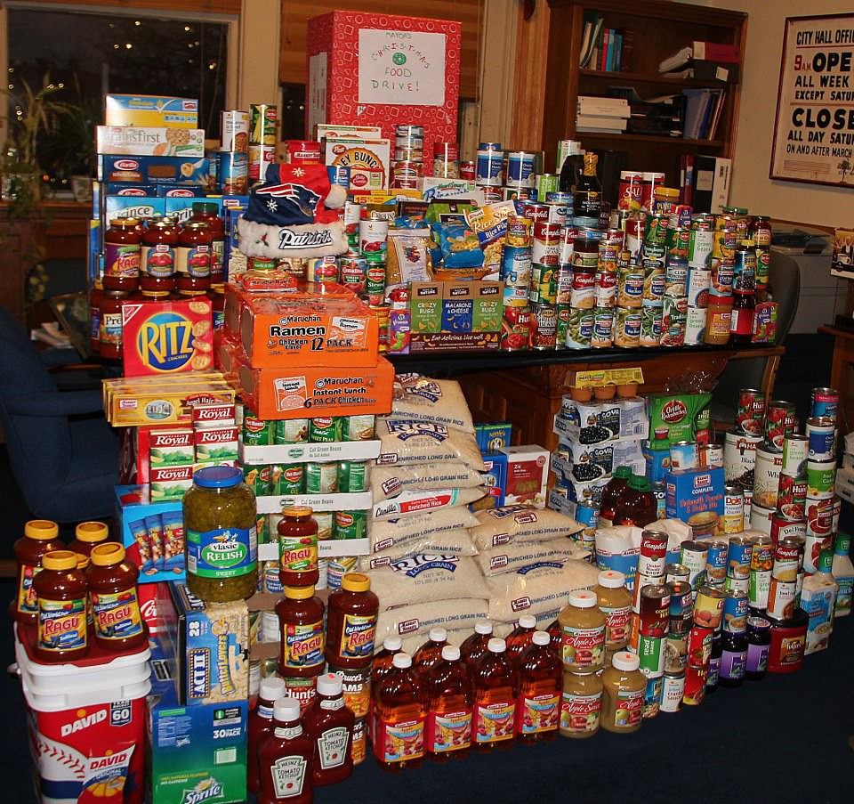

American Legion Family
“Let’s Have a Food Drive”
Date: Place:
Time: Contact:

